Mediator Design Pattern
Friday, June 19, 2020
4:14 PM
Definition:
It's used to handle communication between related objects.
All communication is handled by the Mediator and The Colleagues don't need to know anything about each other.
GOF: Allows loose coupling by encapsulating the way disparate sets of objects interact and communicate with each other. Allows for the actions of each object set to vary independently of one another.
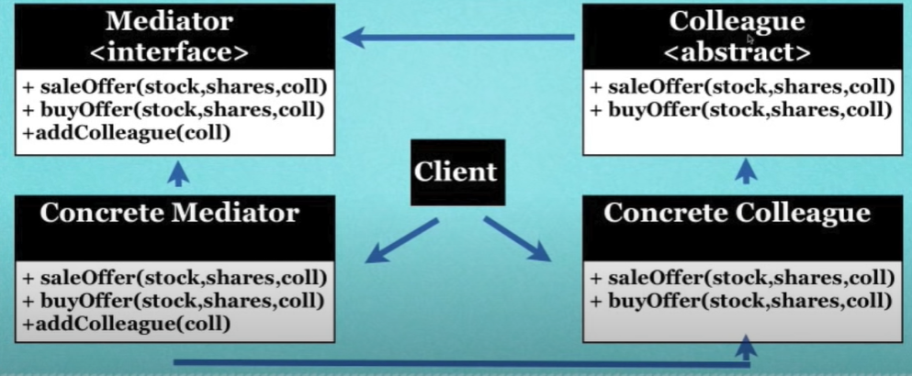

A类和B类的对象都包含同一个中间类M的对象和引用，A类和B类可以通过中间类M来通信。
中介者模式优点：减少了各个Colleague的耦合，使得可以独立地改变和复用各个Colleague类和Mediator。中介者模式可以从更宏观的角度去看整个问题。
中介者缺点：Colleague类多了以后，中介类会变得很复杂。
中介者模式一般应用于一组对象以定义良好但是复杂的方式进行通信的场合，以及想定制一个分布在多个类中的行为，而又不想生成太多的子类的场合。
Personal:
处理逻辑基本都放在Mediator里。

Created a Mediator M
Create A and B, both ctors accept M as parameter, And in the ctors of A and B will add their instances to M's list or sth
Hence, M contains A and B, and A and B contains M. Once A call sth to trigger M to call sth in B

